**Original Paper**

Pradeep K. Ray1,2, Pan Chongdan1, and Mingzhong Wang3

1. University of Michigan Joint Institute (UM), Shanghai Jiao Tong University (SJTU), China, Pradeep.ray@sjtu.edu.cn
2. World Health Organization Collaborating Centre on eHealth, University of New South Wales, Australia
3. University of Sunshine Coast, Australia

# Telepresence Robots for Healthcare Management: COVID-19 Experience

**Background:** Researchers have been investigating the use of robots in the world for elderly in various types of applications, such as communication with relatives and friends at a distance, transportation of medical supplies and equipment across healthcare/aged care facilities, surgical procedures etc. In China, ground zero of the COVID-19 outbreak, robots are being used in hospitals to deliver food and medication and take patients' temperatures. Drones are deployed to transport supplies, spray disinfectants and do thermal imaging. This paper will focus on telepresence robots that have become critically important to perform remote healthcare operations, complying with social distancing measures. UNSW and University of Sunshine Coast have been partners in the European Union VictoryaHome (VH) project (2014-2016) that involved Australia and EU countries Norway, Sweden, Netherlands and Portugal. The project was aimed at better emotional health of the elderly and the project identified some major problems, such as the high cost of robot and its high complexity, making their adoption difficult. This led to the project “Robots for Elderly” as part of the new “Robots for Elderly” project (involving Australia, China, Bangladesh and EU) in mHealth for Belt and Road (mHBR) Initiative led by the UM-SJTU Joint Institute in China from 2018..

**Objective:** The aim of this study is to design, implement and test a low-cost telepresence robot for healthcare. The focus has been on implementing a low-cost telepresence robot for healthcare management for the elderly during pandemics like COVID-19.

**Methods:** This project uses a innovative, multi-disciplinary collaboration across disciplines (software, electronics engineering, mechatronics and public health) involving young university talents from these fields.

**Results:** According to preliminary customer feedback, the main functions have already been realized by our robot. The cost is approx. A$600, about 20 times less expensive than the Giraff robot used in the VH project.

**Conclusions:** Many groups all over the world have been trying to develop low-cost robots for various applications. We addressed the needs for the healthcare of elderly, most affected by the Coronavirus and came up with a simple low-cost design of telepresence robot that can be deployed widely in hospitals and aged care establishments. The system is currently in a prototype level and will require an entrepreneur to commercialize it in large scale.

**Keywords:** telepresence robot; elderly people; telehealth; hospitals, aged care establishments.

## Introduction

Between year 2000 and 2050, the population aged above 65 years will double from current 8% to 16% in the world [1]. In Australia, the number of senior citizens aged over 65 years is projected to nearly double its population from 13.5% of a population in 2010 to 22.7% by 2050 [2]. It is estimated that China will have 250 million old people from 2020, yet currently available nursing centres have limited capacity, thus resulting in a scarce of caregiving resources. Therefore, there is a growing demand for wellbeing monitoring technologies, including falls detection systems, remote health monitoring, smart home technology and video surveillance which would provide them with a feeling of security and independence [3].

Telepresence Robot is a smart self-driven robot providing entertainment and Pharmaceutical features, which can be controlled by caregivers remotely. Telepresence robots are robots that provide two-way communication between two persons, which may assist in aiding the maintenance of social networks in older adults. Instead of being operated by the elderly, the robot can be controlled by caregivers’ cell phones or computers since the elderly often hesitate to handle smart electronic devices. When caregivers are away from the elderly, they can still control the pad on the robot to provide some visual or audio entertainment. Additionally, medicine can be delivered to the elderly through the robot. Thus, for the technical part, one can combine robot technology with tablets so that it can provide medication dispensation and services in addition to video communication. These robots can also act as avatars for medical staff (e.g., doctors and allied health professionals) during the outbreak of a contagious diseases, such as SARS, COVID-19 etc to save the infection to physicians and care givers.

The total estimated market size for elderly healthcare will reach about 300 billion RMB, where nursing homes account for 40%, which is 120 billion RMB. One can target the market of nursing homes because caregivers can control the robot.

This paper is organized as follows. The Section 2 provides a summary of the most popular telepresence robots in the market today. This is followed by a discussion in Section 3 of telepresence robot applications during COVID-19, mostly in China. The Section 4 discusses the development of this low-cost telepresence robot by a multi-disciplinary team. The Section 5 discusses the design using QFD matrices and the prototype. Section 6 discusses the laboratory testing of the robot and its basic functions. Section 7 discusses the contextual evaluation of the prototype by people from the largest Aged Care Establishment in China followed by the conclusion in Section 8.

## The existing telepresence robots for the elderly

Robotic technologies used for healthcare can be divided into nine categories; companion, telepresence, manipulator service, rehabilitation, health-monitoring, reminder, domestic, entertainment and fall detection/prevention robots. Most telepresence robots available in market are not focused the elderly, for instance: Giraff, Double etc. However, during the design and development of these 'off-the-shelf' products, there was less consideration given to the needs and expectations of older people [4]. Some research findings have demonstrated the importance of addressing human factors in design ICT products to attain the positive impact on the wellbeing of the elderly [5-6]. The following subsections will discuss the existing telepresence robots from the perspective of the elderly.

### Giraff robots

The Giraff robot was originally created by Giraff Technologies AB, a small to medium enterprise (SME) based in Sweden, and later further developed within the scope of the VictoryaHome project [9]. The Giraff robot is a large machine, which includes a full-size desktop computer tower plus batteries. It has the ability to raise and lower the interaction screen, change the screen angle (like nodding the head of the Giraff), zoom the camera on a specific area, switch to night vision for dark rooms, and finely control the speed and manoeuvrability of the machine.

Evaluations of the device were in the form of a controlled research trial with the results meant to inform further development of the device in order to provide a solution that would, as closely as possible fit the needs of older people living in their own homes. The trial was extensive with 20 private homes of elderly users, across Europe and two more in Australia. As the trial was designed to determine the usefulness of the Griaff robot, a series of questions were asked both from the primary user (the elderly) and the secondary users (the caregivers) perspective.

The Giraff can be remotely activated by a 'secondary user' (care workers and loved ones who want to contact the primary user using the telepresence robot) to request a visit to the 'primary user' (the older person). The primary user can see an image of the caller on the Giraff screen and can either accept or reject the incoming call. Some secondary users can also be given permissions that allow them to make 'emergency' calls, where they can activate the Giraff and start a visit without any intervention by the primary user, in order to check the well- being of the primary user as may be the case with a suspected fall.

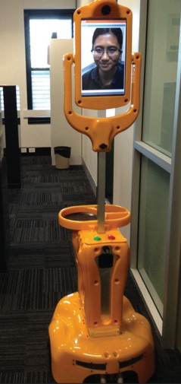

The Giraff robot has been evaluated in various sites in Europe (7) and at two sites in Australia. However, it still have some problems such as firewall issues, video freezing, and driving lag etc, but it can be a reference based on which we can design and build our own telepresence robot.

### Double

. [10]

### NEWME

Business Breakthrough (BBT) University graduate students in Tokyo, who weren't allowed to have a traditional graduation ceremony due to coronavirus concerns, have used Newme telepresence robots to stand in their place [11].

The students appeared on tablets that were placed over the robots' 'faces', using a Zoom conference call to access the ceremony remotely.

To ensure that the students would be properly attired for their important ceremonies, the robots were dressed in black graduation gowns and caps.

When a graduate's name was called, the avatar robot moved to the university's president, Omae Kenichi, who stood on stage to receive their diploma, much like a more traditional graduation ceremony.

Newme robots have also helped people with debilitating paralysis to return to the workplace as robot waiters in Japanese cafes, proving that the potential for these technologies really are limitless.

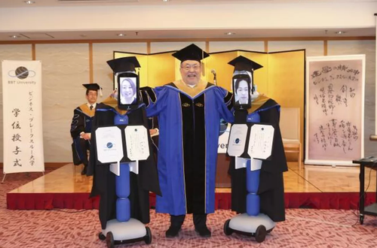

BBT University President Kenichi Omae poses with the students who are using robots to attend graduation. (BBT University), [https://www.9news.com.au/world/japanese-robots-replace-students-university- <https://www.9news.com.au/world/japanese-robots-replace-students-university-graduation-due-to-coronavirus-isolation/d49a56ce-bfa1-4545-b6c5-0dd85344e34b>graduation-due-to-coronavirus-isolation/d49a56ce-bfa1-4545-b6c5-0dd85344e34b](https://www.9news.com.au/world/japanese-robots-replace-students-university-graduation-due-to-coronavirus-isolation/d49a56ce-bfa1-4545-b6c5-0dd85344e34b), April 7, 2020

### KUBI

If using Zoom, controls and the video conference are all wrapped in to one app (Zoom does charge a monthly fee in the neigborhood of $15/month).  Otherwise, users will need to have a window for the Kubi control app, and a window for their video conferencing app op

## <https://telepresencerobots.com/robots/kubi>

Ming to complete the review of telepresence robots

## Telepresence Robots used during Coronavirus Outbreak

Since the Coronavirus is highly contagious, telehealth and mHealth has become very important to protect various types of service providers, particularly health professionals (e.g., doctors and nurses) from infection by patients and clients who may not know that they have an infection in view of the 2 week incubation period. While hospitals are focusing on patients with confirmed Coronavirus infection and its effects, the society has to deal with people who are do not have confirmed coronavirus infection, but they may be suspected (e.g., people coming from a cruise).

There have been many news reports of the use of telepresence robots during the coronavirus outbreak and the main types are:

1. Remote temperature monitoring at public places like airports and also tests for coronoavirus: A system developed by Chinese tech giant Baidu – best known for its search engine – is being used to [screen train passengers in Beijing](https://www.scmp.com/tech/policy/article/3049215/ai-firms-deploy-fever-detection-systems-beijing-help-fight-coronavirus). It harnesses infrared and face detection technologies to detect fevers in anyone passing through the station. Register a temperature of 37.3 degrees Celsius or higher and the systems flags prompting a secondary check.

Baidu has said the system can check more than 200 people per minute, with a margin of error within 0.05 degrees Celsius [12].

2. Remote consultation between health professionals (doctors, nurses etc.) with patients using the tablets: In a bid to minimize person-to-person contact, artificial intelligence-powered devices equipped with thermometers and cameras are taking patients’ vitals and helping doctors diagnose people with the illness from a safe distance [14].

3. Contactless delivery of food and medicines: In China’s southeastern province of Guangdong, an area identified by the World Health Organisation as a coronavirus hotspot, doctors at the city’s Provincial People’s Hospital have been using robots to deliver medicine and food to patients. The two-wheeled droids, shaped like a small refrigerator, can navigate the halls of the hospital autonomously, opening and closing doors where necessary to reach infected people in quarantined areas of the hospital [13].

4. Disinfect rooms with  ultraviolet light and remove germs1:   The Odense, Denmark-based company [is scaling up](https://www.therobotreport.com/coronavirus-fight-china-gets-boost-uvd-disinfection-robots/) to meet global demand. Shanghai-based TMiRob [has deployed](http://www.xinhuanet.com/english/2020-02/07/c_138763788.htm) 30 disinfection robots across hospitals in Wuhan, the epicenter of the COVID-19 outbreak. Wilmington, Mass.-based [**Xenon Corp.**](https://xenoncorp.com/) provides UV-C lamps to **[Xenex Disinfection Systems](http://www.xenex.com/" \t "_blank)**. San Antonio, Texas-based Xenex’s robots are designed to reduce healthcare-associated infections in hospitals, and it claimed that its LightStrike UV robot [**is already in use**](https://www.jpost.com/HEALTH-SCIENCE/Robots-take-on-coronavirus-618551) in 500 facilities in the U.S [15]. Meet Sadie. She's one of 32 germ-zapping robots Honor Health hospitals now have to clean patient rooms and the ICU with UV light. It gets rid of the residual viruses and bacteria and spores [16].

5. Replace hospital reception staff with robots to answer questions by patients and family members: One such machine is the Temi robot. Developed by an Israeli company, Temi is three feet tall and features a touchscreen, Amazon’s Alexa technology, a built-in sound system, a tray for charging phones and an autonomous navigation system that allows it to move around on its own while avoiding obstacles [14].

Having seen these different types of applications of a telepresence robot for both aged care and for COVID-19, we now discuss the development of a low-cost telepresence robot suitable for both aged care and for COVID-19.

### The Development of Low-Cost Telepresence Robot

As stated in the background, this project started with the experience of the team in the EU Victoryahome project [8]. Hence the initial specification was taken from the robot used in the VictoryaHome project for which trials were carried out in Australia, Norway, Netherlands, Portugal and Sweden. This involved robots controlled remotely by carers or family members (see video at <https://www.youtube.com/watch?v=o2VhThCzFwg>). This project Giraff robots with facilities for medication dispensation and fall detection, in addition to the tablet screen for interaction between remote carer and the elderly at home.

This project encouraged innovative students of UM-SJTU JI, led by Pan Chongdan who led the SJTU team to the World championship in robot design in 2019. Students were encouraged to form a multi-disciplinary team consisting of JI final year students in Mechanical Engineering, Electrical and Computer Engineering and largest Aged Care company (Haiyang group) in China. The main strategy has been to exploit recent advances in embedded computing (Raspberry Pi), tablet based low-cost robot display and mechatronics dynamics for the robot. The design uses Quality Function Deployment (QFD) matrices from the Total Quality Management (TQM) domain.

The design problems and innovations can be summarized as:

### 1 Budget

The budget is under $1000 while the products in the market were much more expensive than that (at least $3000), which implied that it the focus would be on the Minimally Viable Product (MVP). So the main problem was to redesign, simplify the robot and realize the essential functions at a low cost.

### 2 Communication Technology

The core technology of telepresence robot is to establish stable and simple connection between the controller and the robot. Since firewall and routers are often used, there are many obstacles impeding the transmission of control signal. What’s more, since the caregivers will keep moving, so the mobility of such control system is very important.

### 3 Stable Control System

To realize available control between the caregivers and the robot, core processor, actors and sensors are essential. First we need to control actuators by giving instructions to the core processor connected the network. Then feedbacks will be given by sensors so that the caregivers can know the status of the robot. One of the most important task for our team is to create a available interface between the robot and caregivers so that they can control it smoothly.

### 4 Functions for the elderly

It’s important to realize functions specially for the elderly. Since the elderly usually have different needs and different characteristics, the robot should be able to cope with different kinds of people. For example. different old people have different pills to eat at different time, so the medicine dispenser should be flexible enough to coordinate with it. It should be able to dispense various pills at once.

### 5 Safety and Power

Since usually the elderly usually stay with the robot alone, safety is very important and the nominal voltage shouldn’t be too high, which is less than 30V. In addition, the robot should have a battery of high capacity so that it doesn’t need frequent charging because it’s hard for the elderly to bow and connect with the power supply manually.

Therefore, the customer requirement for our project is set based on main problems of the current product.

* The robot should be simple and cheap enough, which costs less than $1000 but still keeps its essential functions.
* Caregivers can have full control of the robot even when he is very far away from it. The remote control system should only have short lags and be free from firewall interruption. When caregivers drive the robot remotely, there should be a navigation system for him so that he can view the surrounding situation. The robot structure should be very stable to avoid trumbling.
* Caregivers and the elderly can use this robot to make video and audio call to each other with acceptable lags and clarity. They should able to see each other’s face clearly and hear what they say through the robot.
* Caregivers can control the robot to give pills to elderly with a stable dispenser. The robot should be able to store the pills for a long time when caregivers is away and the pills won’t go bad.
* Different customers can make minor change to the robot for individual customization.

## 4.1 Hardware and Software Components of the Robot

### Raspberry Pi

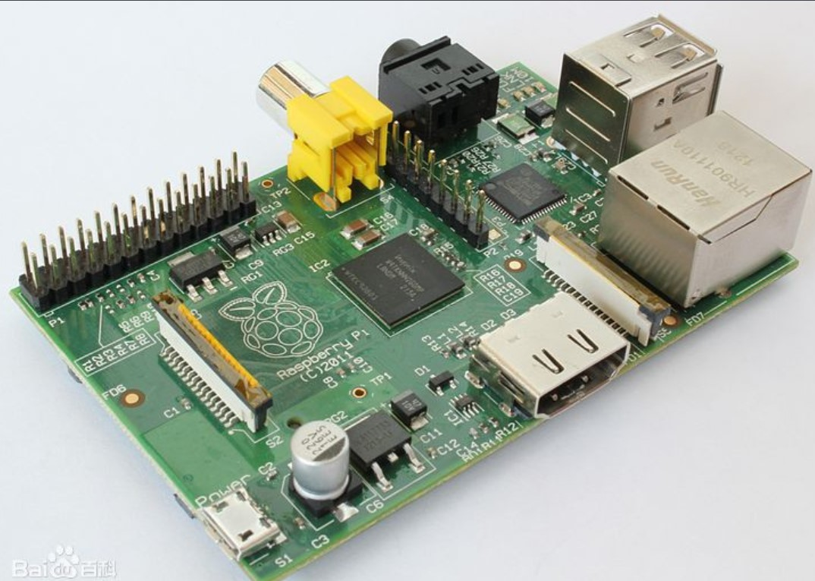Figure 2: Raspberry Pi Board

Raspberry Pi is a micro computer with many I/O interface so that it’s easy for us to develop and control functions based on it. In addition. sin raspberry has its own linux system, we can write some control codes and realize Internet connection through it. Raspberry Pi can be a good central core for the telepresence robot.

#### TeamViewer

Figure 3: TeamViewer

TeamViewer is a software developed by Germany which can provide stable remote control between different computers. What’s more TeamViewer can be applied on any devices connected to world wide web as long as it has its own operating system. TeamViewer is an important technology to realize stable remote control and control mobility of telepresence

#### Screen, Camera and other Actuators and Sensors

There is big screen which can be connected to the Raspberry Pi. With such screen, the elderly can communicate with the caregivers visually and freely. On the other hand, camera like opencv can get pictures from the elderly or the surrounding environment for the caregivers so that they can control the robot and contact the elderly more easily. Actuators and sensors will play an auxiliary role for realize such functions.

### Medicine Dispenser

**Background** More than 50% of the older people are living with multiple chronic illnesses[**?**]. Thus, routine monitoring and assessment of the individuals adherence is crucial to improve their health outcomes. Elderly with multiple chronic conditions face the complex task of medication management that can involving multiple medications of varying doses at different times. Advances in tele-health technologies have resulted in home-based devices for medication management and health monitoring for the elderly[**?**]. The function of such medication dispensers is to alert the patient when it is the date and time to take their prescribed medication[**?**]. When the time comes to take the medication, the pill dispenser automatically releases a pre-measured dose for consumption. Some of the features are:

* Provides audible, visible or vibration alerts.
* Dispenser must be locked once medicine is replenished.
* Long distance connectivity to track use.
* Humidity resistant and tamper proof.
* Dispense only the prescribed amount at the required times.

**Mechatronics**

This is the wheeled base (chassis) of the robot with motors that can be controlled remotely. Considering the end user of our product, the design of chassis requires a lot of considerations as well. First of all, it should be stable enough to support a one meter-long aluminum rod with a bunch of components installed on it. It should have the required mobility such that it can move freely in narrow places at home. Also, it should have enough space to plant electrical components and batteries, and cover them well so that no dangerous components are outside to hurt the elders.

## 4.2 Specifications

The custom requirements of our project are divided into the software and hardware part. They are summarized as follows:

**Hardware**

1. The screen, along with its control buttons, should be large enough.
2. The speaker should be loud enough for the elderly.
3. The height of the screen should be suitable for old people who sit in a chair to watch.
4. The medicine dispenser should be located on a suitable height.
5. The medicine dispenser should have large storage.
6. The medicine dispenser should provide dry environment to store the medicine.
7. The moving speed of the chassis should not be too fast or too slow.
8. The battery duration of the robot should last a long time.
9. The physical entity of the robot does not contain any sharp edges.

### Software

1. Control (both local and remote) of the robot should be easy.
2. Alarm function should be added to remind the elderly to take medicine.

Besides these requirements from the two aforementioned categories, the total cost of the robot should be below $1000.

Considering the robot itself, we separate the robot into the following four functional parts: 1) Chassis of the robot, 2) Medicine Dispenser, 3) Touchscreen & camera, 4) Raspberry Pi controller. The generated engineering specifications, along with the custom requirements are shown in Table. **??** and Fig. **??**.

|  |  |  |
| --- | --- | --- |
| Item | Unit | Target Value |
| Speaker Loudness | dB | 80 |
| Moving Speed | m/s | 0.2-0.5 |
| Remote Control Lag | sec. | *<* 0*.*2 |
| Video Lag | sec. | *<* 1 |
| Battery Capacity | mAh | 20k |
| Cost | US Dollar | *<* 1k |

### Table 1: Specifications

1. **DESIGN PROCESS USING QFD**

The Quality Function Development matrices help design systems from relatively vague customer requirements by quantifying them through the QFD process, resulting in a matrix as shown in Fig 4, where we list 12 customer requirements and 10 engineering specifications, rate their relationships, and calculate the priority. Each strong relationship counts 9 points, each moderate relationship counts 3, and each weak relationship counts 1. Multiply by the importance points of the requirements, we can calculate the weighted average of each specification. The specification with highest weight has the highest priority. We found out that the remote control lag is the most important one, and the motor power and the weight follow. The least important one is the dB of the speaker.

Figure 4: QFD table of our project.

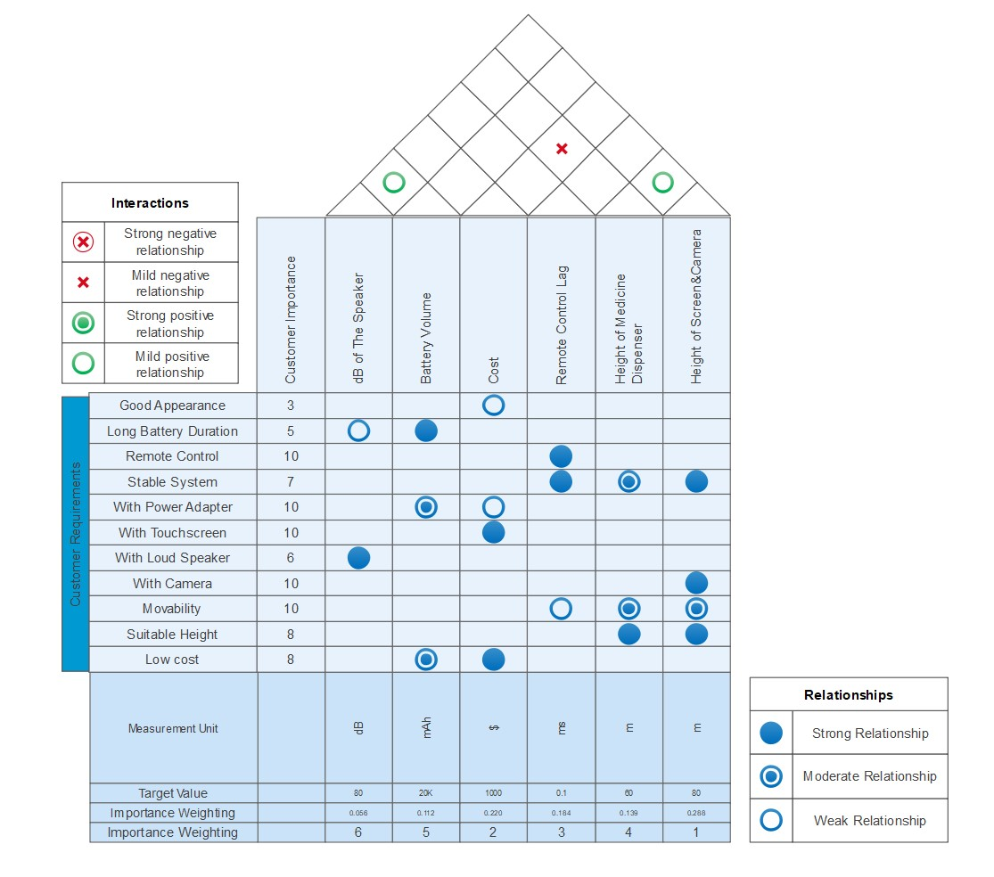

## Once the priorities of the design are decided, one needs to select from several design choices using Pugh’s concept selection method. This will now be illustrated in the context of the design of the Medication Dispenser.

## 5.1 Medicine Dispenser

For our medicine dispenser concepts we had to keep in mind our budget restraints, our end user, and the safety standards. Which meant that the design had to operate with few electrical components (motors, servos, etc..), to be simple enough to cheaply 3D print, to be easily handled by the elderly and their caregivers and to comply with the safety standards (mainly correct dosages, tamper proof and humidity proof), shown in Fig 5.

The two concepts that were generated were based on the way that the pills would be sorted and delivered to our users:

* **Mixed Pill Manual Sorting**: the daily medication would have to be sorted by the caregiver and the cocktail of medication would have to be put into each slot manually. The dispenser would then rotate at the desired time so that the medication that was in the next slot would fall into a tray and be consumed by the user.
* **Pill Blocks Automatic Sorting**: would have blocks in which each block would contain one type of medication, and the system would separate them automatically depending on the demand. The system would dispense into a tray the desired amount of each pill at the designated time. Each block would have its own mechanism to make sure that only a single pill would be released at a time, so that the user would have the correct dosage of medication.

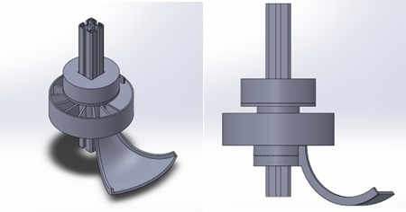

### 

Figure 5: Pill Dispenser

#### 5.2 Concept Selection Process using QFD Pugh Method

With both our medicine dispenser designs, the and the Pill Blocks Automatic Sorting being plausible choices for our needs, we will construct a scoring matrix in order to compare them with our requirements (price, user and safety) in order to ensure the best results. Figure 6 provides the matrix for comparison between the two concepts and the selection based on the best choice.

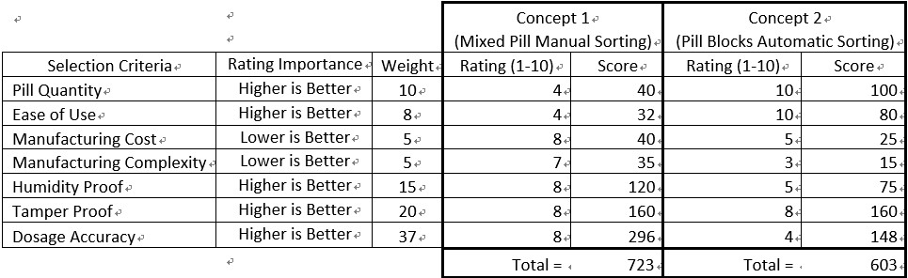

### Figure 6: Concept Selection Scoreboard

We can see from the criteria and the weights that the safety aspects of our medicine dispenser outweigh the usability and cost. Therefore since our Mixed Pill Manual Sorting concept has a higher score we have chosen to pursue this design.

**Dispenser frame**: our initial design was built with 31 partitions for one month use of dosages, but the pills were to be directly deposited into each partition; this was a problem because the pills would move with the dispenser frame while they scrapped against the bottom dispenser which is fixed. The last issue with our frame was the lack of a locking mechanism to keep the pills tamper proof. Our solution to these problems was to decrease the number of partitions to 15 for two weeks of use, making each partition big enough to fit a pill box, which would simultaneously keep the pills humidity proof and prevent them from scratching against the bottom dispenser.

**Bottom Dispenser** the first design of the bottom dispenser was a curved half sphere shape so that the pills would be able to slide toward the center closer to the support beam, and be able to slide easier when reaching the pill tray, but this design was quickly modified due to the difficulty of 3D printing and the introduction of our pill box.

**Pill Tray** in order to make it easier for the users to access their medication, a pill dispenser was designed with a slide shape to ensure the safety of the medication once it was dropped from the dispenser. The slide design was modified because of the difficulty to 3D print the design as well as the change from individual pills to the pill box, which would mean the tray would have to catch a little box full of pills instead of multiple individual pills.

In our completed design iteration in below we can see that all the necessary components are designed and bought (bearing, stepper motor and lock) or 3D printed (gearbox, gears, dispenser and pill tray) to meet our engineering specifications and requirements.

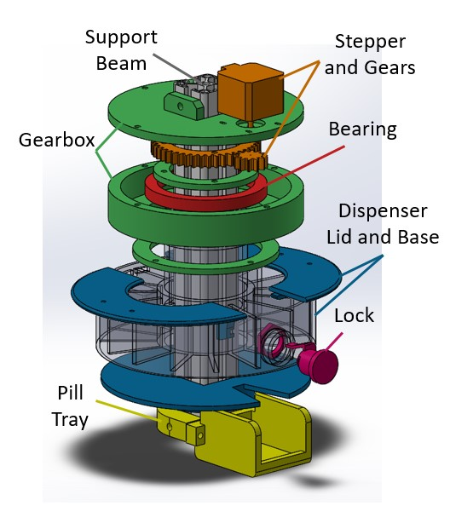

### Figure 7: 3-D View of Medicine Dispenser

Our chosen concept has five sections as we can see in Fig. 7. The stepper motor, gears and bearing (orange and red) are responsible for the movement of the dispenser base. The support beam (silver) is connected to our chassis, and it supports the gearbox, bottom dispenser base and the pill tray which are all fixed to it. The gearbox (green) houses the moving parts so they are safely away from the users as well as keeps the dispenser suspended and rotating freely with the bearing. The dispenser lid and base (blue and transparent) house the pill boxes and keep them humidity proof. The lock (pink) locks the dispenser lid in place so that once the pill boxes are inside the dispenser they are tamper proof. And finally the pill tray (yellow) receives the pill boxes once they drop from the dispenser, making it easy for the user to administer the drugs.

* 1. **Mechatronics Implementation**

This Section presents the final implementation of the mechatronics part of the design.

## Chassis

We use the universal balls at the front and the back, so that the weight center of the robot will not change during turning process. The driving wheels are directly connected to the motors, which are controlled by a Raspberry Pi just near them. Aside of them, are batteries supplying power for both chassis and upper components. Also, a square hole is prepared for the aluminum rod, so that the connection between chassis and upper components are stable (Figure 8).

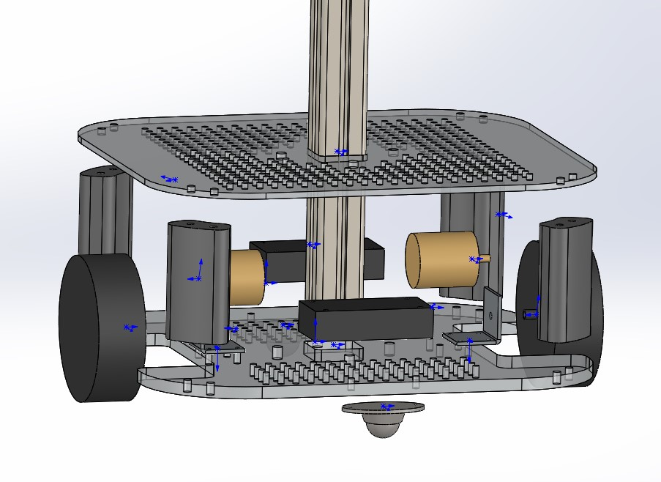

Figure 8: Explosion View for Chassis Design Ver.2

## 5.4 Software Implementation

From the software side, the engineering specifications and custom requirements of our design indicates implementation in the following three areas:

1. The control system which control the movement of the chassis
2. The communication system that allows remote control of the robot
3. The video streaming system

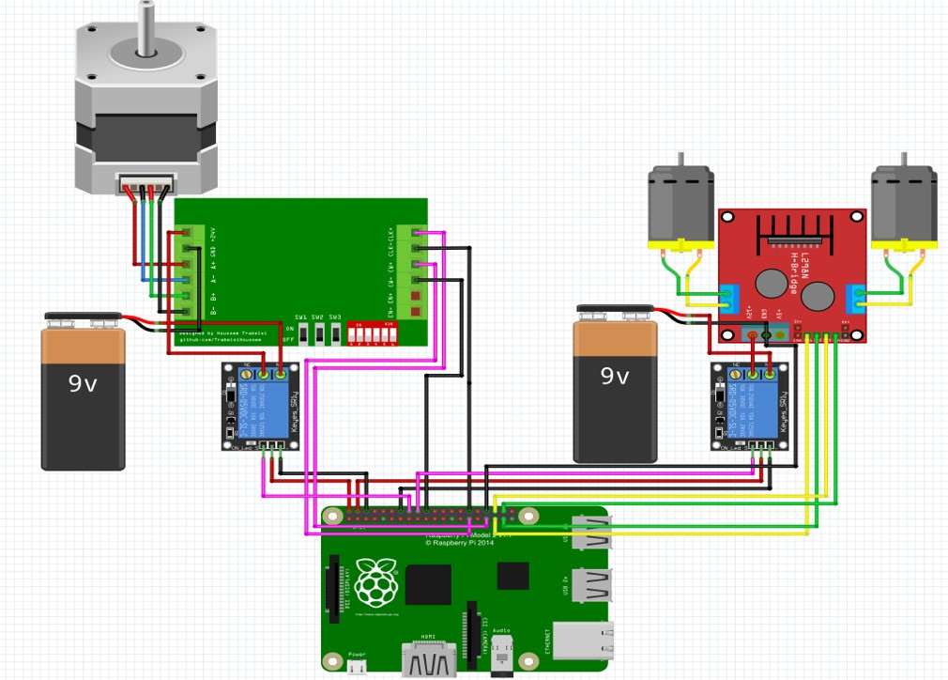

Figure 9: Circuit Design of the Control System

### Control System

The raspberry pi board contains a set of general purposed input output (GPIO) pins. Through these IO pins, we are able to control the movement of the robot. The physical circuit is shown in Fig. **9**. The control program is shown below.

### Communication System

The graphic user interface of the control program is shown in Fig. **10**. The website coding and the script for the website is intuitive. Every time a button is pressed on the website, the website will post a ”/cmd” request to the control program, which will then call the main function. The detailed description for the functions from the bottle library can be found through

### the website Figure 10: User Interface of the Control System

[https://bottlepy.org/.](https://bottlepy.org/./) 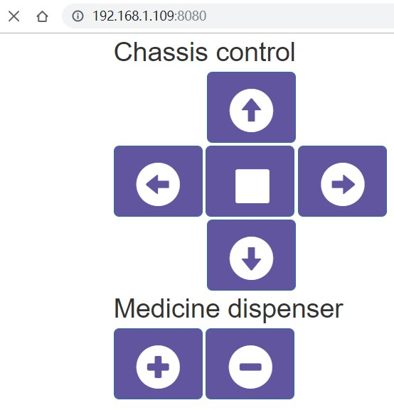

In order to remotely log in the Raspberry Pi and the pad, we need a remote control system. We decide the use a developed software called TeamViewer to realize this function. The inclusion of TeamViewer aligns well with our custom requirement and engineer specifications because it supports multiple platforms and offers stable connection. Also, TeamViewer offers a private communication channel due to the 256 bit AES encryption scheme it adapts.

### Video Streaming System

To realize video communication with the elderly and provide visual guide for remote control of the movement of the robot, we need a video streaming system to give real-time information to the user. We decided to buy a windows tablet on which the video communication system is already implemented. With this tablet, the video communication is very straightforward. We use apps such as WeChat or QQ to realize this function. Also, we can remote control the pad using TeamViewer.

Figure 11 shows the assembled prototype robot. The total cost to us was about 3000 RMB with functions of providing video call, remote movement control, medicine storage and dispensation. The video call and navigation for remote control is realized by a tablet with its camera, the pad can also be used for playing video and entertainment software for the elderly.

Figure 11: Assembled Telepresence Robot Prototype

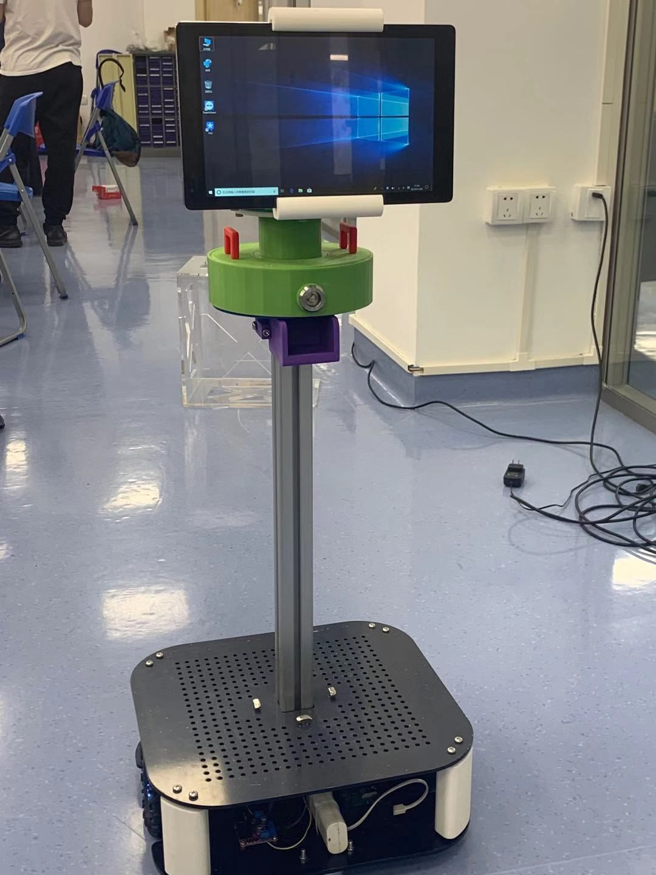

1. **Testing Plan**

There are three major criteria to evaluate the quality of the product: the chassis movement, the medicine dispenser, and the remote video communication. Here we will present experimental set up to test their corresponding engineering specifications. For other engineering specifications such as the loudness of the speaker, the volume of the battery, the height of the screen, and the screen resolution, they can be directly measured or validated by reading the manual for each component used.

### 6.1 Chassis movement

To set up this experiment, a clear field is needed with a line of length 5 meters measured. The robot is placed at one end of the line. At the other end, a chair with person sit on it should be placed in a different direction with the robot. Through remote control, the robot should be able to forward in a straight line for the 5 meters, and then turn to the person. The user that control the robot cannot see the situation in the field directly. He or she can only move the robot using the view provided by the camera on the robot.

In this experiment, we will validate the moving speed of the robot and the video streaming specification.

### 6.2 Medicine dispenser

The experiment is set up in 10 rounds. In each round, we fill in the medicine dispenser with pills. Then we rotate the dispenser 14 times and see if the pills can be correctly dispensed. The number of failures are recorded. In each round, pills with different weights should be applied.

In this experiment, we will validate the functionality of the medicine dispenser, as is required by the engineering specification.

### 6.3 Remote video communication

To perform this experiment, we need another stable video communication tool as a reference. We turn on the video communication utility of the robot and the reference tool at the same time. Then a third person will shoot the video conference using a camera. By analyzing the time delay between the streaming of these two tools, we are able to get the delay of the video communication utility of the robot.

In this experiment, we will validate the engineering specification for the video communication lag.

# 7 Evaluation

This evaluation involved a contextual enquiry i.e. an interview of the Aged Care Experts with the telepresence robot prototype developed by us. The full text of the interview is enclosed in Appendix-A. It may be noted that we also needed to find out the suitability of the robot for elderly care in China, as the initial specification came from the European sources.

According to customer feedback, the main functions have already been realized by our robot. However, we still need to do some improvements

In addition, we will try to add voice interaction to our robot. Since the robot is equipped with windows 10 system, the internal voice controller Cortana can play an important role in it. Also, we can slighlty modify the interface and system of the robot so it can support multiple language. As mentioned in customer feedback, multiple language support is very essential, it can help us get more users. We also need to improve the system so that it can run many mobile application which specially made for the elderly. Currently, they can only run on IOS or Android system, we want to make them compatible with our robot.

Here are the process charts that illustrate the suitability of this telepresence robot for the five scenarios of COVID-19 applications discussed in Section 3.

Each of these scenarios has two charts, one is flow chart, showing the working procedure of these robots, the other is architecture chart, showing the robot’s control structure. Since the second scenario and fifth scenario is very similar, so they will share the same chart

In the following diagrams, bold text represents for existing functions for telepresence robot but functions with grey texts are not applied in the specific scenarios. Italic text represents for functions in need of other attachments like systems or sensors. Normal text represents for existing function but only be applied in specific scenarios.

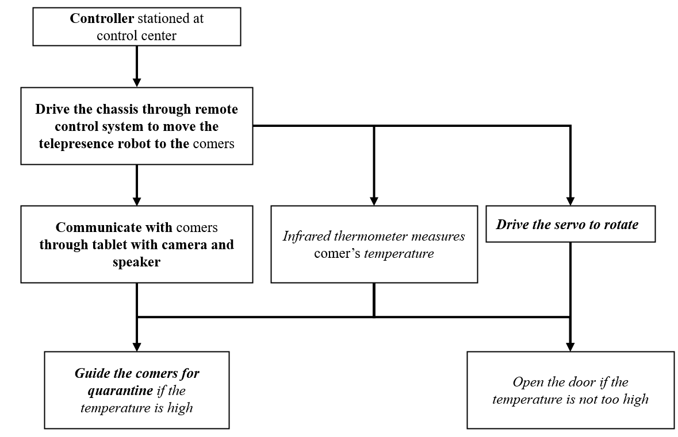7.1 Remote temperature measuring

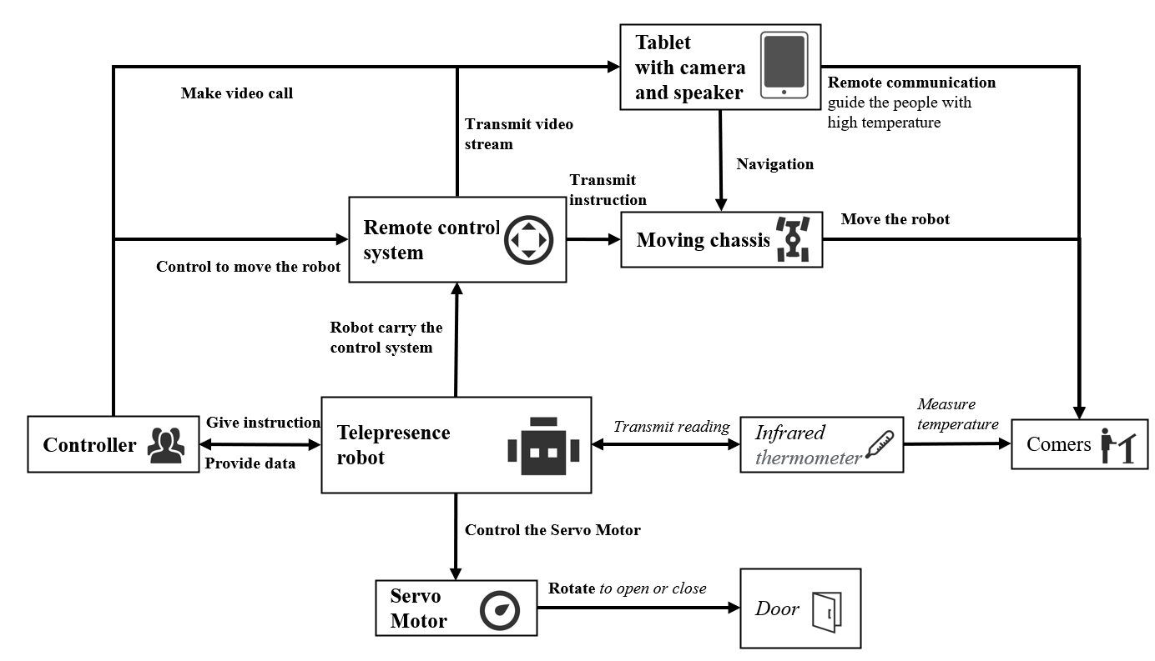

7.2 Remote consultation and reception for medical service

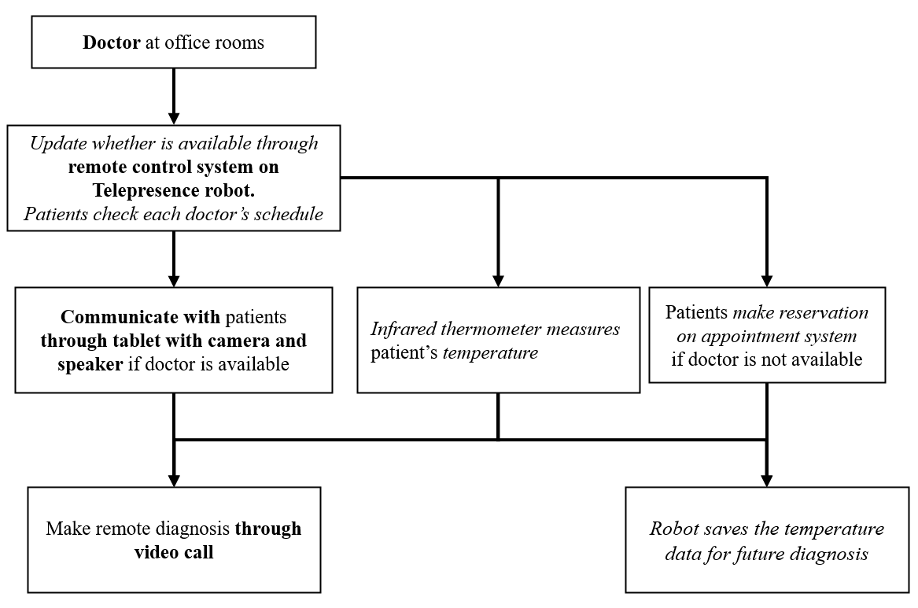

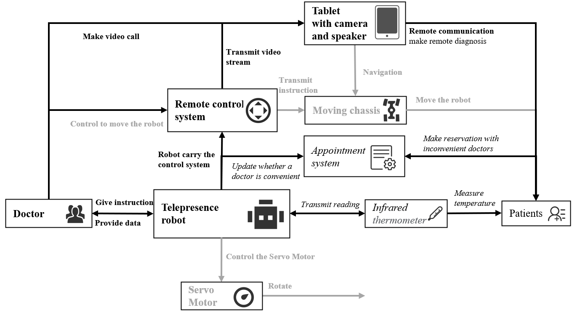

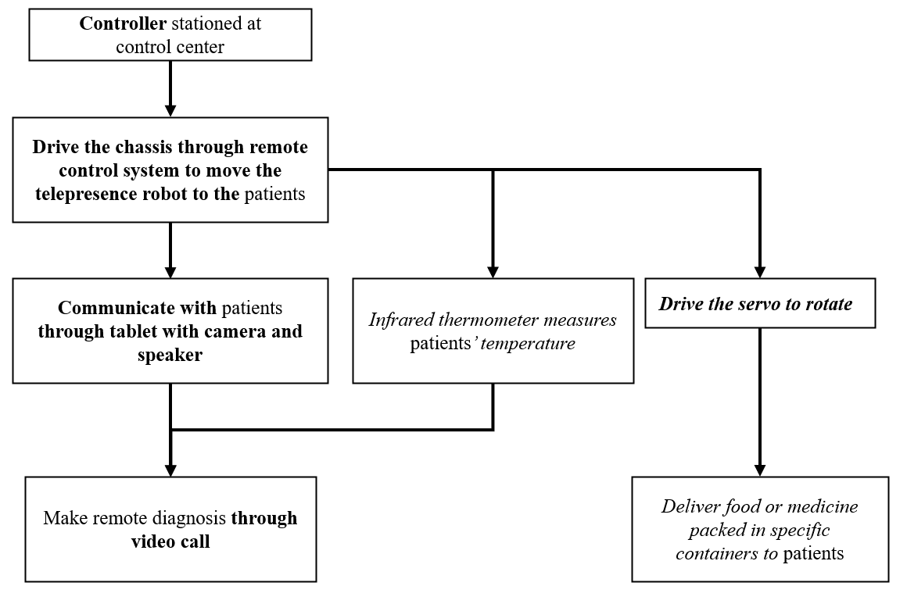7.3 Contactless delivery of food and medicines

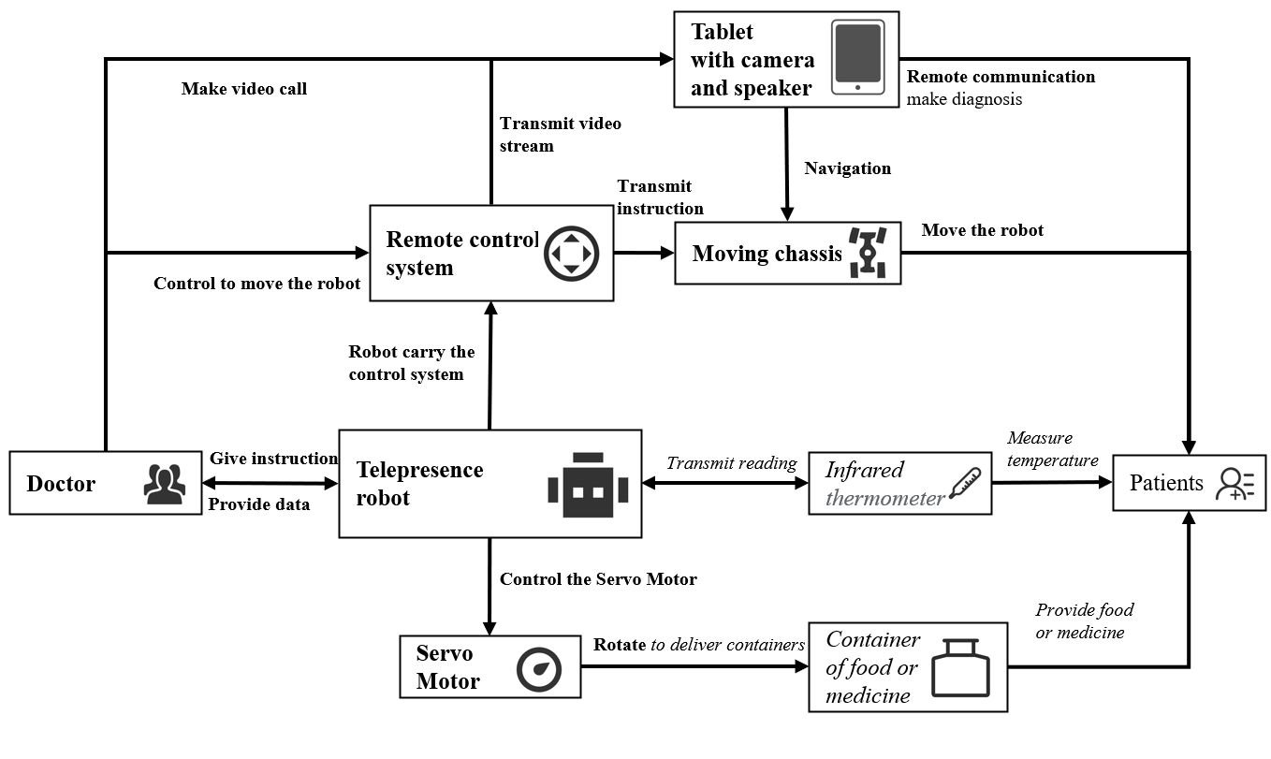

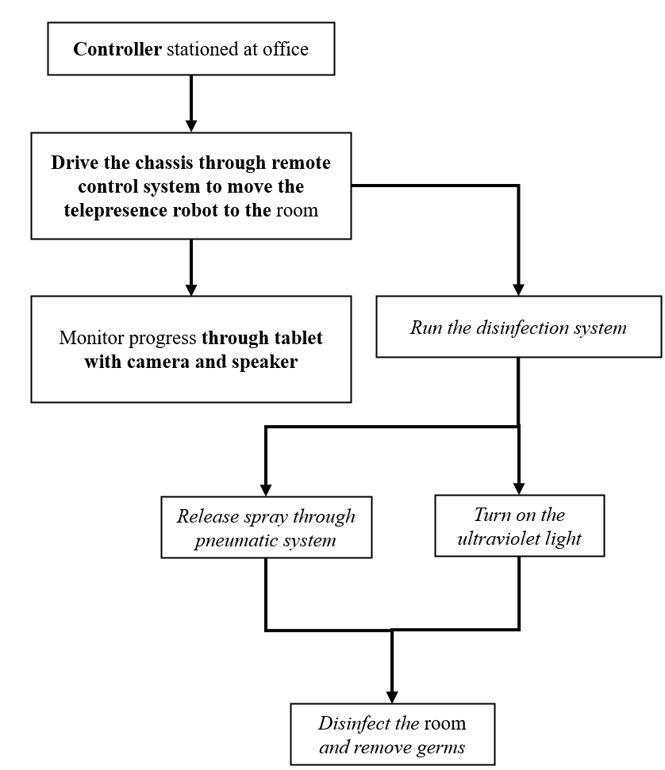7.4 Disinfect rooms and remove germs

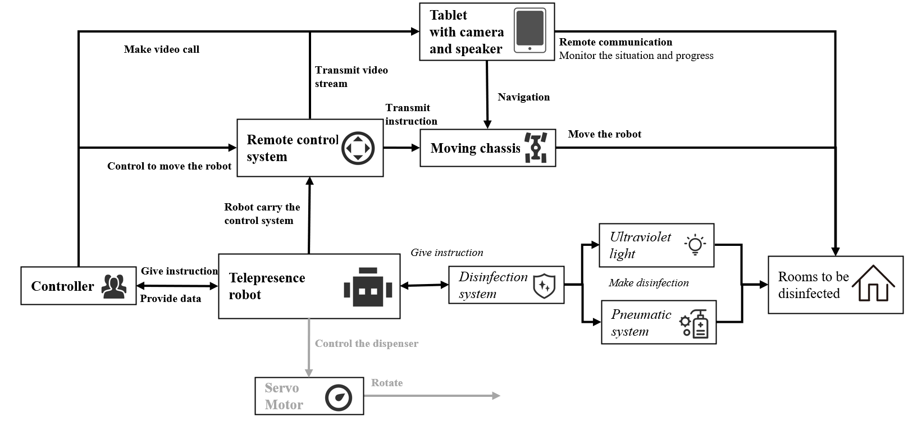

# 8 .

# Conclusions

Telepresence robots are still a relatively new technology in which a person can transmit his presence by controlling a robot with his projection on a screen, the idea is that someone can be present in the room even though they are located anywhere in the world. Telepresence robots can be particularly useful for elderly care, where family members can control the robot and give attention to the elderly on a more regular basis, with additional functions such as being able to monitor the medication intake and being alerted when a fall has been detected. However, current telepresence robots for the elderly are expensive according to the users[**9**] , around 5 to 15 thousand dollars for a model, the persistent connectivity issues also make it hard to operate and control, causing a negative feedback from the elderly and caretakers alike[**9**].

The infectious nature of pandemics like COVID-19, makes it necessary for telepresence robots to be used (between patient and health professionals) to reduce the chances of infection. Hence these robots are now being used extensively in hospitals all over the world.

Our goal for this project was to design and build a telepresence robot for the elderly that has a desirable price point of less than 1 thousand dollars, while maintaining the features such as medicine dispenser and fall detection provided in the EU Victoryahome project. Also the operation is simpler, improving the user experience. The initial cutomer feedback is encouraging but more thorough evaluation is needed.

## Acknowledgment

The project was partly supported by the capstone project team of the UM-SJTU Joint Institute in Shanghai, China. This is to acknowledge the support of the Leader of VictoryaHome project Prof Artur Serrano of NTNU, Norway for his support in the Robots for Elderly Project in mHBR. Authors would also like to thank A/Prof Donald Kerr of the University of Sunshine Coast for his leadership role in mHBR Robots for Elderly Project.

**References**

1. Pew Research Centre. Attitudes about aging: a global perspective. 2014.
2. National Seniors Australia. The future of aged care in Australia. 2010.
3. Miskelly FG. Assistive technology in elderly care. Age and Ageing. 2001;30(6):455-8.
4. Steele R, Lo A, Secombe C, and Wong YK. Elderly persons’ perception and acceptance of using wireless sensor networks to assist healthcare. International Journal of Medical Informatics. 2009;78(12):788-801.
5. Demiris G, Charness N, Krupinski E, Ben-Arieh D, Washington K, Wu J, and Farberow B. The role of human factors in telehealth. Telemedicine and e-Health. 2010;16(4):446-53.
6. Wu YH, Fassert C, and Rigaud AS. Designing robots for the elderly: appearance issue and beyond. Archives of Gerontology and Geriatrics. 2012;54(1):121-6.
7. Moyle, W., Jones, C., Cooke, M., O’Dwyer, S., Sung, B., and Drummond, S. 2014. "Connecting the person with dementia and family: a feasibility study of a telepresence robot," BMC Geriatrics (14:7).
8. Robots vs. coronavirus: Automated delivery, cleaning and imaging against a pandemic (2020, March 12) retrieved 12 March 2020 from https://medicalxpress.com/news/2020-03-robotscoronavirus-automated-delivery-imaging.html
9. Donald Kerr, J Artur Serrano, Pradeep Ray, ”The role of a disruptive digital technology for homebased healthcare of the elderly: Telepresence robot,” Digital Medicine, Year 2018
10. <https://www.doublerobotics.com/>, April 8, 2020
11. <https://ohmnilabs.com/content/custom-robotics-development-ana/>, April 8, 2020
12. [**Fighting coronavirus with data, analytics, AI... and robots**](https://istart.com.au/news-items/fighting-coronavirus-with-data-analytics-ai-and-robots/)**,** <https://istart.com.au/news-items/fighting-coronavirus-with-data-analytics-ai-and-robots>, accessed April 11, 2020
13. [**China unleashes robots in its battle to control coronavirus**](https://www.telegraph.co.uk/technology/2020/02/10/robots-battling-coronavirus-outbreak/)**,** <https://www.telegraph.co.uk/technology/2020/02/10/robots-battling-coronavirus-outbreak>, accessed April 11, 2020
14. [**Robots take on coronavirus - The Jerusalem Post**](https://www.jpost.com/HEALTH-SCIENCE/Robots-take-on-coronavirus-618551)**,** <https://www.jpost.com/HEALTH-SCIENCE/Robots-take-on-coronavirus-618551>, accessed April 11, 2020
15. [**Coronavirus response growing from robotics companies**](https://www.therobotreport.com/coronavirus-response-growing-robotics-companies/)**,** <https://www.therobotreport.com/coronavirus-response-growing-robotics-companies>, accessed April 11, 2020
16. [**Germ-zapping robots at Scottsdale hospital kills ...**](https://www.azfamily.com/news/germ-zapping-robots-at-scottsdale-hospital-kills-coronavirus-nearly-of/article_6c51bd7a-4a29-11ea-a561-97d8243c6f02.html)**,** <https://www.azfamily.com/news/germ-zapping-robots-at-scottsdale-hospital-kills-corona>, accessed April 11, 2020
17. https://gss1.bdstatic.com/9vo3dSag xI4khGkpoWK1HF6hhy/baike/crop%3D56 %2C0%2C520%2C343%3Bc0%3Dbaike80%2C5%2C5%2C80%2C26/sign=f63045 cb3ffae6cd18fbf12132863908/78310a55b319ebc4d65ed2658826cffc1e171623.jpg
18. Yap, A.F.; Thirumoorthy, T.; Kwan, Y.H. Systematic review of the barriers affecting medication adherence in older adults. Geriatr. Gerontol. Int. 2016, 16, 6993a7001
19. Reeder, Blaine, et al. aOlder Adults Satisfaction with a Medication Dispensing Device in Home Care.a Informatics for Health Social Care, U.S. National Library of Medicine, Sept. 2013, www.ncbi.nlm.nih.gov/pmc/articles/PMC4122419/
20. Sumo Guide. aBest Automatic Pill Dispenser - Top 10 Reviews 2019.a Sumo Guide — The Ultimate Shopping Guide Product Reviews, Sumo Guide Team Https://Sumoguide.com/Wp-Content/Uploads/2016/09/SumoGuide-Logo300x100.Png, 31 July 2019, sumoguide.com/best-automatic-pilldispenserreviews/.
21. American Society of Health-System Pharmacists. ASHP guidelines on the safe use of automated dispensing devices. Am J Health-Syst Pharm. 2010; 67:483a90.
22. Reeder, Blaine, et al. aOlder Adults Satisfaction with a Medication Dispensing Device in Home Care.a Informatics for Health Social Care, U.S. National Library of Medicine, Sept. 2013, [www.ncbi.nlm.nih.gov/pmc/articles/PMC4122419/](http://www.ncbi.nlm.nih.gov/pmc/articles/PMC4122419/)

**APPENDIX A**

**JI Group:** Can you please introduce your daily work?

**Haiyang Group:** I’m the dean of the nursing home, and I manage the whole nursing home including annual plan, staff responsibilities, coordination with people from inside or outside, connection with the government and cooperation with other charities.

**JI Group:** Who does your nursing home mainly serve.

**Haiyang Group:** The elderly and disabled. We don’t take psychopaths or patients with infectious disease.

**JI Group:** What kind of service do you usually provide for these people?

**Haiyang Group:** We take care of them, provide them with food, help them take a shower, and help them see a doctor. We also hold different kinds of events to make them happy and provide mental care and support.

**JI Group:** You will only invite people from the community to these events or people outside?

**Haiyang Group:** Both. Some volunteers from the university for the elderly will join our events. They will also make some performance for the elderly here. Elderly nearby will also join these events.

**JI Group:** From the pictures posted by you on WeChat, these old people looks very happy.

**Haiyang Group:** Yes, you can come to our nursing home and see it by yourself. So that you can understand their needs and life.

**JI Group:** We really want to go to your nursing home and see it, but we are too busy this semester. We know there are two kinds of service for the elderly, including community support for the elderly and service support. What’s the difference?

**Haiyang Group:** I can’t give you the exact answer, I only run an institution for the elderly. I think community support for the elderly is like daycare.

**JI Group:** What difficulties do you think exists in the service for the elderly.

**Haiyang Group:** From my point of view, many old people and relatives don’t want to go to nursing home because of their old concept. We also lack professional staff to provide service.

We don’t have much income and revenue so we can’t attract the young people by providing them with high salary.

**JI Group:** Can you talk about more details about the shortage of professional staff?

**Haiyang Group:** We lack nurses, doctors and nursing assistant. Actually, we have enough people, but we lack people who meet our requirements. This problem can’t be solved by remote healthcare, we need these people on the scene to serve the elderly. The government also have such requirements for the number of people on the scene.

**JI Group:** Let’s see a video of a healthcare telepresence robot. This is a prototype that we’re working on.

**Haiyang Group:** The elderly will use these robots at home?

**JI Group:** Either at home or in the nursing home. We plan to use this robot to provide medicine, diagnosis, and remote video communication.

**Haiyang Group:** Based on Chinese law, only nurses with certificate can give medicine to the elderly. It doesn’t matter if you only use the robots at home, but we’re supervised by the government in nursing home and they have specific requirements.

**JI Group:** From nursing home’s view, what kinds of role can robot play to serve the elderly?

**Haiyang Group:** The robot that can play with the elderly, or design a game for them, or provide 24-7 care for the elderly. These old people usually feel bored since they can only lie in bed and can’t move. They’ll also feel lonely since nursing assistant can’t always stay with them. Robots can tell stories for them, but there may exists a language barrier since China have many kinds of localism. Some of our elderly people want to speak and practice localism but the robot can only speak mandarin. This video shows the old people are doing physical exercise. Robots can teach them how to do some exercise. Robots can also help take videos or photos, since our monitoring system has blind spots.

**JI Group:** We’re thinking whether robots can provide some physical interaction with the elderly, like playing games.

**Haiyang Group:** My husband’s company make rehabilitation robot. The elderly tends to be paralytic after getting sick. Robot can help them exercise limbs. Robot can also record the elderly’s songs and play the recording. But some old people may not have a clear mind, so they may destroy the robots.

**JI Group:** So we must make these robots very strong. What else can you think of except for these functions?

**Haiyang Group:** Many old people can’t read, so it’s better if the robot can be controlled by voice. Nurses are not quite familiar with how to operate a computer, so the robots’ user interface should be very simple. In addition, robots here also require WIFI or Internet, so they are unstable. You can set some sensors on the robot, so when the elderly fall or yell “Help me”, it can notify the nursing station.

Patrol robot may also be quite useful, like they will check every room and take a picture in the evening. Nowadays, we go on patrol everyday by ourselves.

**JI Group:** Do the elderly accept robots. Will they be afraid?

**Haiyang Group:** Those with a clear mind won’t be afraid.

**JI Group:** Can we use robots to hold volunteer service. Volunteers can chat with the elderly through screen, camera and speaker on robots.

**Haiyang Group:** Yes.

**JI Group:** From the video of robots, can you mention some defects or defaults?

**Haiyang Group:** Whether can use a robot to deliver a medicine depends on the law.

**JI Group:** From our design, we want to let nurses control the robot to deliver the medicine. So it’s not fully automatic.

**Haiyang Group:** There is a risk since the robot may give the wrong medicine.

**JI Group:** What if there is someone supervising the robot?

**Haiyang Group:** It depends on the law. There will be serious consequence if the elderly eats wrong medicine.

**JI Group:** It seems more practical if the robots are used to play with the elderly.

**Haiyang Group:** Yes, they also need a stable chassis.

**JI Group:** If we modify the robot prototype so that it can interact with the elderly, how much would you like to pay for it. A price for reference is 7000 RMB.

**Haiyang Group:** It’s too expensive. The price we accept is a litter higher than a tablet, like 3000 RMB. But it also depends on the robots’ functions.

**JI Group:** What function will satisfy you most?

**Haiyang Group:** Accompanying old people, monitoring their status or social interacting with them. But the robot must be suitable for them. I heard Japan have some tablets especially for the elderly. All apps on the tablet are specially designed for the elderly.

**JI Group:** We’ve found some robots mimicking animals.